

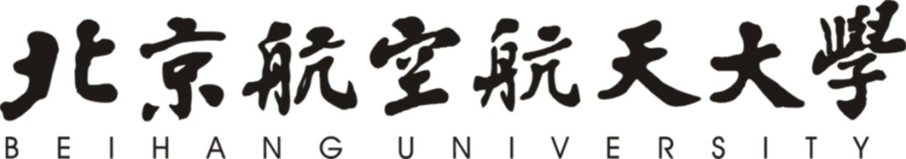

调研报告

内容（名称）：美国文化负载词调研

|  |  |
| --- | --- |
| 课程名称 | 高级英语（3） |
| 课程院（系） | 外国语学院 |
| 学号 | 76066002 |
| 姓名 | 周美廷 |
| 院（系）名称 | 计算机学院 |
| 专业名称 | 计算机科技与技术 |

2019年12月

**The True Translations of See's Nuts & Chews**

1. **Background**

In the 10th page of the English version of the article, the writer mentioned See’s Nuts & Chews, along with other snack names. In the 程乃珊译本 version, it is translated as 各种干果和口香糖 while in the 田译本 it is translated as 西伊果仁口香糖. Both of the translations are definitely not the right translation as See’s Nuts & Chews is not what it sounds to be like.

1. **Research**

The first step of the research would be by looking on to the company’s official website which is sees.com. After searching on Google for “See’s Nuts and Chews”, their official website is finally found.

And this is what we have:

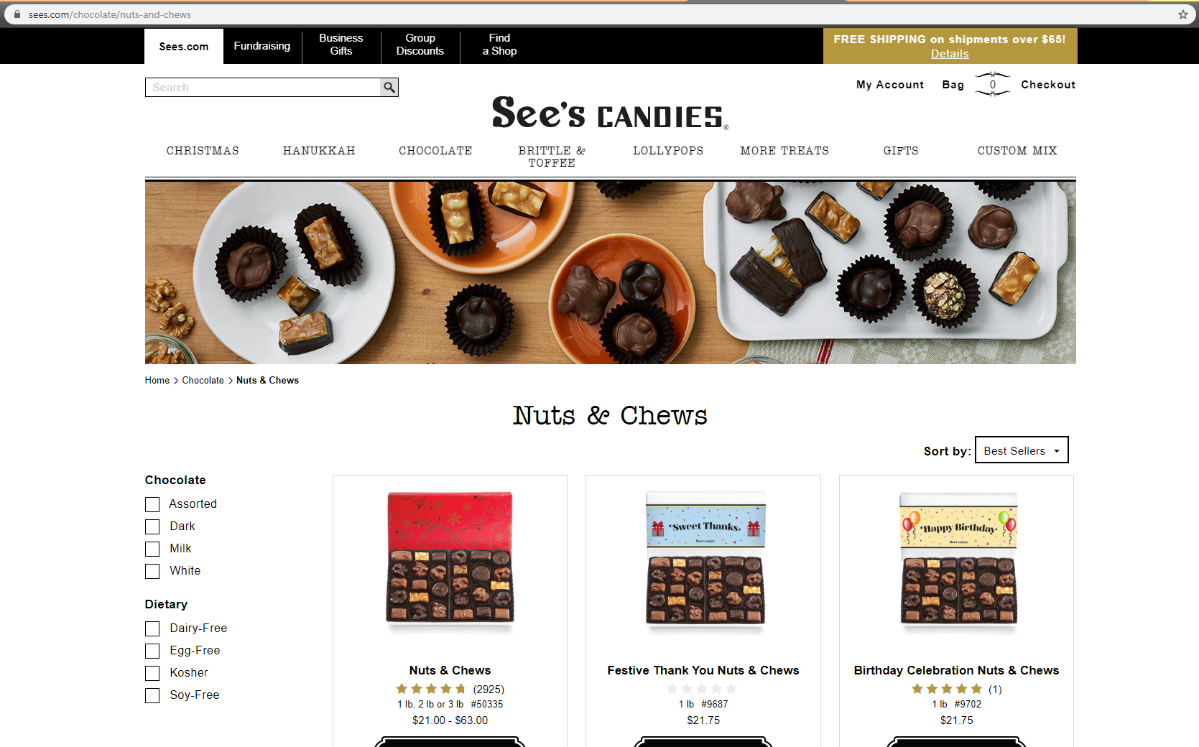

Even by looking at all the pictures that are covering the page, we can already guess what See’s Nuts and Chews is: yes, it is a **chocolate product**. To be exact, it’s a **nut-filled chocolate**.

Now, putting the brand name aside, which leaves us with “Nuts and Chews”, I tried to translate it on Google Translate which literally gives me this:

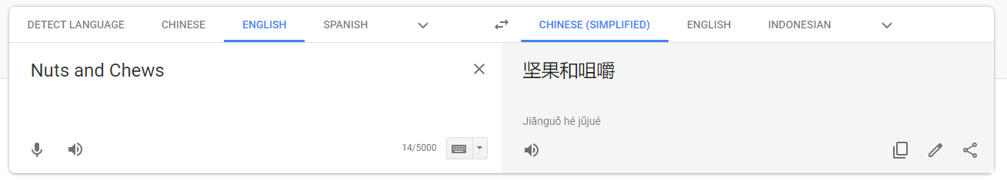

It is an undeniable fact that the food name itself says Nuts and Chews instead of directly saying “Chocolate” or something similar. So, let’s separate **Nuts** and **Chews** and try to understand the word again. Nuts can be translated to 坚果 ，干果or 果仁 and both are not wrong, but what about Chews?

In a literal explanation, **Chews** means **anything that can be chewed**, even pet foods. Yes, pet foods, because the Google search gives this:

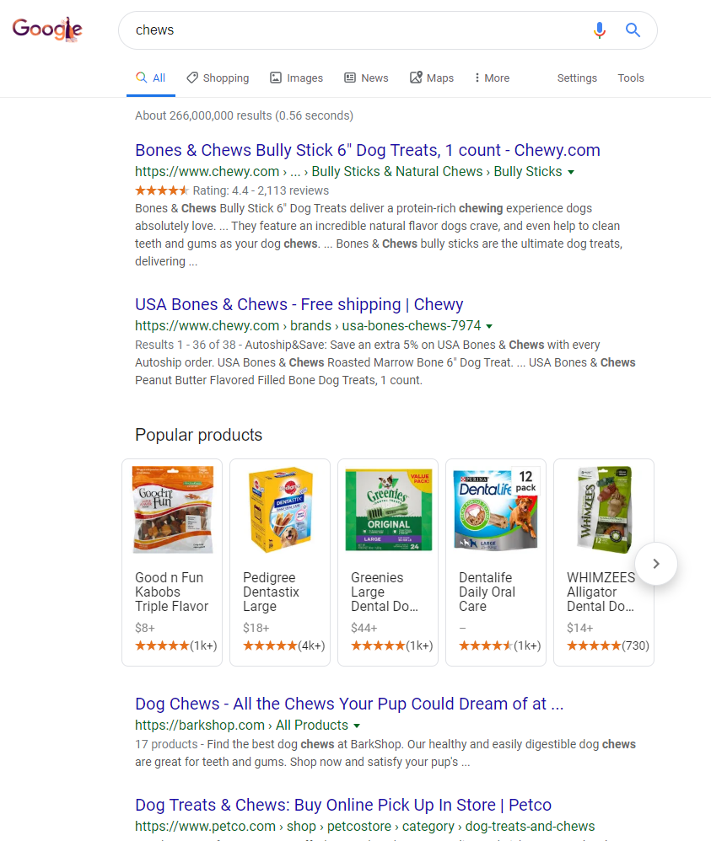

By a cognitive understanding, we can relate **Chews** to candies and candies to sweets, and then finally sweets to chocolate, which is why **Chews** can literally mean anything that can be chewed, including chocolate in it. Therefore, it is impossible to directly translate something as general as **Chews** before or without really knowing what this **Chews** is referring to.

We can see that in both 程乃珊译本 and 田译本, **Nuts** is translated to 干果 and 果仁 respectively, which is all right. Meanwhile, **Chews** is translated as 口香糖. It’s obviously not the right translation for the following reasons:

1. I mentioned that **Chews** is a general reference, it can refer to anything that can be chewed, even something like pet foods, which is obviously not a human food. But 口香糖 is not at all a general reference (口香糖 means **Chewing Gum**).
2. A Chewing Gum *is* something that can be chewed, it even has **chewing** on its name, but **Chews** doesn’t necessarily mean gums or any other candies. The translation process can’t fully depend on the fact the **chewing gum** has **chewing** on its name.

After all the explanation, we now go back to the fact that See’s Nuts and Chews is indeed a chocolate product and not-at-all related to gums. Therefore, the translation 口香糖 is definitely wrong.

Now that the translation technology is getting better, we can find out what people in China call this product as, and the search on Baidu results in this:

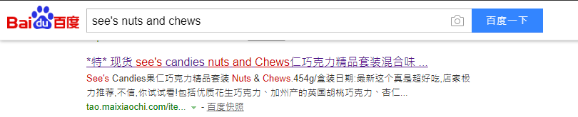

It says 果仁巧克力精品套装 which, again, can’t be directly translated using tools such as Google Translate because it gives us this:

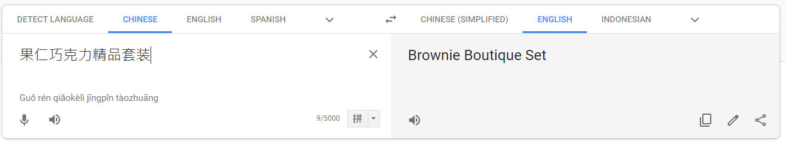

Only by understanding the product itself can we make the right translation, be it Chinese-English or vice versa.

1. **Conclusion**

The explanation on part 2 explains everything related to See’s Nuts and Chews and the possible reason of why the translations could go wrong. From all the information above, See’s Nuts and Chews can be divided to **See’s**, **Nuts**, and **Chews**.

The first one: **See’s** is the brand name, which may or may not be directly translated to Chinese depending on the brand owner—whether they have the Chinese translation of it. If it doesn’t, we have to translate it based on how it sounds, which means the 田译本 got it right, as it translates **See’s** as 西伊.

We already know that the **Nuts** translation got no problem so we’re left with **Chews**. The conclusion is simple, it’s translated as 巧克力, which only the ‘understanding-translation’ from an online shop on Baidu got it right.

The last thing is, as we can see from the product’s official website that See’s Nuts and Chews is all displayed as a whole set of chocolate, means that this product is not a single product, so in the Chinese translation we should include the word **Set**.

By combining all the words that we’ve got, See’s (西伊), Nuts (果仁), Chews (巧克力), and Set (套装), the true translation of See’s Nuts and Chews must be **西伊果仁巧克力套装**.